OFFICIAL COORDINATION REQUEST FOR
NON-ROUTINE OPERATIONS AND MAINTENANCE
COORDINATION DATE- 1 October 2009
PROJECT- Bonneville Dam
RESPONSE DATE- 06 October 2009
Description of the problem- Smith- Root, Inc. is working with the USGS – BRD (i.e., Matt Mesa) to evaluate the efficacy of a non-lethal sea lion deterrence array. The group proposes to evaluate the deterrence array in the UMT at BON Powerhouse 2. Fish behavior is proposed to be recorded through the use of a DIDSON acoustic camera. To avoid adverse hydraulic effects of mounting the DIDSON in the UMT, the researchers are proposing to deploy the DIDSON from a small raft floating in the UMT during the duration of the study.
Prior to initiation of the study, the researchers need to verify the field of view for the DIDSON to assure adequate monitoring can be accomplished. To accomplish this objective, the DIDSON camera will be mounted the bottom of a small pontoon raft. This assembly will then be lowered into the UMT. Researchers will then verify the field of view for the DIDSON. Observations on fish behavior in the vicinity of structure will also be made.
Type of outage required- No outage requested.
Impact on facility operation- No impacts.
Length of time for repairs- No more than one day. This work is proposed to be scheduled the week of October 12.
Expected impacts on fish passage- Minimal. The raft measures approximately 6 feet long by 3 feet wide. The raft is expected to extend into the water column (i.e., draft) less than two inches. The DIDSON is about one square-foot in size. The camera will be installed to the underside of the raft. The camera is expected to draft less than 8-inches. Earlier proposals considered mounting the DIDSON on the bottom or sides of the UMT. This installation will reduce any hydraulic impacts.
Installation will require no interruption of facility operation. The raft and camera assembly will be lowered by hand into the UMT. The assembly will then be secured by ropes through the duration of the evaluation. The assembly will be removed immediately after completion of the necessary testing.
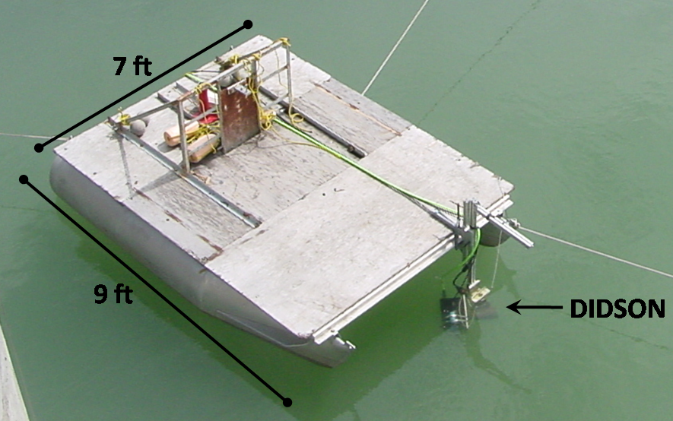
Comments from agencies- FPOM says ok to an hour test after 12 October.
Final results-
Please email or call with questions or concerns:
Shane Scott (on behalf of Smith Root, Inc and USGS – BRD)
Cell: (360) 601-2391 sscott06@earthlink.net

